Ground-dwelling arthropods associated with *Ephedra californica*

Braun, Jennaa,*; Westphal, Mikeb; and Lortie, Christopher J.a,c

**\***Corresponding author

a) Department of Biology, York University, 4700 Keele St. Toronto, ON. Canada

braunj@yorku.ca

b) Bureau of Land Management, Central Office

c) NCEAS

**ABSTRACT**

Max 300 words

**KEYWORDS**

Facilitation; diversity; ephedra; residual dry matter; arthropod

**INTRODUCTION**

Insect conservation and their importance to arid ecosystems

Insect conservation is becoming increasingly important. Further, arid ecosystems account for 41% and are one of the most sensitive in terms of global changes to biodiversity and vegetation shifts (Sala et al., 2000; Schroter et al., 2005). In arid ecosystems, arthropods mediate resource flow and structure the surrounding community (Whitford, 2000). Further, ground dwelling arthropods including Coleoptera and Orthoptera are the major component of the diet of Gambelia sila, the federally listed lizard (Germano, 2007). Ground-dwelling arthropods are important to arid ecosystems as they are critical components of food webs and nutrient cycles, as well as altering soil nutrient regimes (Lobry de Bruyn 1999). Therefore, insect conservation is of direct interest to land managers looking to manage and encourage species at risk. Therefore insect community dynamics are of importance to managers looking to support biodiversity.

Shrub facilitation for other plants in arid ecosystems is a well-established set of interactions to biodiversity maintenance in these systems (Filazzola and Lortie etc). A growing body of work is showing the importance of shrub canopy facilitation for arthropod communities within this ecosystem. (Groner and Ayal [2001](https://link.springer.com/article/10.1007/s11829-016-9450-z#CR10); Polis [1999](https://link.springer.com/article/10.1007/s11829-016-9450-z#CR28)). Sanchez and Parmenter ([2002](https://link.springer.com/article/10.1007/s11829-016-9450-z#CR32)), Seeber et al. ([2009](https://link.springer.com/article/10.1007/s11829-016-9450-z#CR36)), and Liu et al. ([2011](https://link.springer.com/article/10.1007/s11829-016-9450-z#CR18)), Ruttan 2016, Braun 2019). They also provide keystone structure to ground-dwelling arthropods in Patagonian shrub steppe (Liu, Zhu et al. 2016). However, in the California deserts these studies have been restricted to the spring season when annuals are actively growing. Arthropods depend on plants, vertebrates depend on arthropods and shrubs. Plants depend on shrubs. The relationship between shrub canopy and arthropods is well known. ‘island’effects: Doblas-Mirandaet al.2009;Zhao and Liu2013; general effects: Liet al.2013;Sotomayorand Lortie2015).

In arid regions of California, the growing season as a short period. Land managers have developed a set of protocols to measure the residual dry matter and apply it to several questions relating to rangeland management. If there are indirect effects of shrub facilitation that scale through the annual plants, they may … Foundation plants play a central role in structuring arid environments. Microclimate amelioration and other mechanisms can affect survival, growth, and reproduction of annuals plants. The positive effects of vegetation can propagate through other trophic levels, including both primary and secondary consumers. Complex direct and indirect effects. Residual dry matter (rdm) is a common measure of productivity in drylands. It is comprised of both direct and indirect drivers on plant composition and structure including resource availability, plant-plant interactions, and interactions with consumers. Previous work has found that annual plant productivity, at small scales, is associated with higher abundance and diversity of arthropods within grasslands (Siemann 1998). Habitat-based surrogates are used to indirectly measure biodiversity and are used by land managers in place of expensive intensive surveys (Hughes 2000, Gollan et al 2009). In grasslands, vegetation cover including primary production and structure architecture, as well as interactions among species across trophic levels influence arthropod community structure because vegetation in grasslands provides physical structures as well as the nutritional base for arthropod food webs (Joern and Laws 2013). Previous work has found more complex relationships between shrubs, rdm and lizards. The shrubs facilitate the plants, but interfere with the lizards (Filazzola).

The objective of this study was to evaluate…. We used a survey of ground-dwelling arthropod communities and standing vegetation characteristics in nine sites in three regions in arid California. Due to the importance of physical structure, we expect that the RDM should influence arthropod communities. We hypothesize that shrubs facilitate arthropods. We tested the following predictions 1. More arthropods are associated with shrubs in deserts (abundance and richness). 2) Greater RDM under shrubs. 3) RDM facilitates arthropods. 4) effect of shrubs is influenced by rdm under the canopy. We chose the early summer because it is a period of high ground dwelling arthropod activity, as well as vertebrate breeding time for several species of endangered animal that are under management within these ecosystems that depend on arthropods for a major component of their diets.

**METHODS**

Site description

Between the dates of June 23rd and July 8th, 2019, I sampled 3 sites each within 3 desert regions (Table 1, Figure 1).

Study species

*Ephedra californica* (Ephedraceae) is a…

Residual dry matter

At each site, I chose 30 shrub open pairs. Shrub microsites were located on the northern aspect of the shrub, within the dripline. A 0.5 m by 0.5 quadrat was placed by randomly throwing it under the shrub and the open microsites were chosen by throwing the quadrat over my shoulder and were located at least 2 m away. Within in quadrat, I estimated cover of the residual dry matter, green veg cover, measured the height of the vegetation within the quadrat. I counted the number of burrows under the shrub within the dripline, and at open microsites within a 1.5m radius around the quadrat to approximate the size of the shrub. For shrubs, I measured the length of the longest axis, its perpendicular and the height. I collected all residual dry matter within a 20 cm quadrat placed at the center of the 0.5 m quadrat using scissors ensuring only plants rooted within the quadrat were collected. These were placed in paper bags, and then dried within a *blank* oven at 85º C for 75 hours. The samples were weighed using *blank* scale with a precision of 0.001 g.

Measuring ground-dwelling arthropod communities

We used pitfall traps to sample the arthropod communities at eight shrub/open pairs per site (n = 16 at nine sites). Clear plastic drink cups (10 cm tall, 7 cm diameter) were placed in the center of the 0.5 m quadrat with the top of the cup flush with the ground. The traps were filled with a 50% propylene glycol and water mixture and were deployed for 72 hours. They were checked periodically during their deployment and were topped up with water as needed. Arthropods were sieved and placed in labelled vials containing 95% denatured ethanol. At these microsites, residual dry matter was collected after the traps were collected.

Insects were identified primarily to genus and family depending on the group (see Appendix) using keys (Triplehorn, ant book, fly book) and were morphotyped within those groups. Velvet ants (Mutillidae) were not morphotyped because of strong sexual dimorphism. Only worker and major caste ants (Formicidae) were included in analyses. Springtails (Collembola) and arthropods smaller were excluded due biases arising from sieve mesh size. Larval stages and hemipteran nymphs that could not be associated with the adult form were excluded.

Data analysis

We fit generalized linear mixed models (glmmTMB) to test for differences in arthropod abundance and morphospecies richness between the understory of *E. californica* and open areas. One sample was excluded as an outlier in the abundance model as it had 1200 individuals compared to the rest of the samples were below 350. Microsite and RDM biomass were included as predictors, and the study site nested within the region was included as a random effect. A Poisson error distribution was used for morphospecies richness model and a negative binomial error distribution was used for abundances because overdispersion was detected within the model. We compared models with interactions to models with only additive effects to intercept only models using AIC and likelihood ratio tests (car).

To test for more sensitive differences in the composition of arthropod community, RDA (vegan) was used. Microsite, site, RDM biomass and region were included as constraining variables. The species abundance matrix was Hellinger transformed to account for differences in sample abundance and provide more ecologically relevant information (Legendre etc).

To estimate the biological importance of statistically significant differences we calculated the effect size estimate Relative Interaction Index (RII) (Armas et al., 2004). The equation: $RII= \frac{treatment-control}{treatment+control}$ was used. Treatment is the target response value at the shrub microsite and control is the target response value at the open microsite. This measure ranges from −1 to +1, is symmetric around 0 and is common within plant ecology literature (Armas, 2004). Negative values indicate relative competition whilst positives indicate facilitation (Armas et al., 2004). To determine if the effect was significantly different from 0, 95% confidence intervals around mean values were bootstrapped (boot, Canty 2002) Because some of the pitfall traps were lost, the values were calculated at the site level using a permutation approach were the microsites were paired up randomly and the mean RII and SE were calculated for the sites. For RDM, we calculated RII at the site level, as well as at the individual level.

To test for indirect effects, we used RIIabun and RIIrichness compared with the mean RDM at the shrub microsites??? Maybe just a visual here?

**RESULTS**

A total of ~6300 arthropods were collected, ~170 morphospecies. Ants were the most abundant group (x%, x%morphos), followed by x, x and x.

Arthropod abundance and morphospecies richness were significantly greater under the canopy of *Ephedra californica* than in open areas (Table 2). Contrary to our predictions, there was no influence of RDM biomass on either arthropod response variable (Table 2). The interaction term between rdm and microsite was not significant. There was a significant negative effect of rdm cover on arthropod abundance, but no influence on richness.

Residual dry matter biomass was significantly greater under shrubs (Table), and so was the percent cover of rdm.

RDA results

RII results

Bootstrapped CI results

Correlation coefficients

**DISCUSSION**

The Discussion should place the research results in the broadest possible scientific or management context. It should highlight the important contributions of the work and relate these contributions to published knowledge. The Discussion should clearly state the importance of the work to rangeland ecology or management.

The work of several author’s have shown arthropod island effects (Liu, Zhu et al. 2014, Liu, Zhu et al. 2016)

**Implications**   
  
- shrubs should be managed to maintain biodiversity and productivity within rangelands

* To capture the biodiversity of inverts shrubs should be sampled

All manuscripts should conclude with a brief section (maximum of two paragraphs) that highlights the broad implications of the research. The implications can be either scientific or managerial and reference any aspect of the rangeland profession.

TABLES

Table 1: List of study sites surveyed for this project

|  |  |  |  |  |  |  |  |
| --- | --- | --- | --- | --- | --- | --- | --- |
| Site | Region | Lat | Long | Elevation | MAT | MAP |  |
| Pan1 | Panoche Hills | 36.70654 | -120.812 | 611 | 14.4 | 377 | 2.618056 |
|  | Panoche Hills | 36.70554 | -120.812 | 596 | 14.4 | 377 | 2.618056 |
|  | Panoche Hills | 36.70001 | -120.801 | 656.3209 | 14.4 | 381 | 2.474026 |
|  | Cuyama Valley | 34.84873 | -119.483 | 848 | 13.4 | 533 | 3.701389 |
|  | Cuyama Valley | 34.85362 | -119.486 | 837 | 13.4 | 533 | 3.701389 |
|  | Cuyama Valley | 34.93824 | -119.481 | 827 | 13.4 | 533 | 3.701389 |
| M1 (Sheep hole valley) | Mojave Desert | 35.09405 | -116.835 | 496.02 | 19.7 | 135 | 0.652174 |
| M2 (Heart of the Mojave) | Mojave Desert | 34.6982 | -115.684 | 784.73 | 19.3 | 79 | 0.389163 |
| M3 (Ft. Irwin area) | Mojave Desert | 34.20568 | -115.72 | 545.92 | 20.9 | 109 | 0.497717 |

Table 2: GLMM showing arthropod community responses

Conditional model: Richness

Conditional model:

## Estimate Std. Error z value Pr(>|z|)

## (Intercept) 2.052152 0.135044 15.196 < 2e-16 ***

## Micrositeopen -0.176744 0.064116 -2.757 0.00584 **

## RDM -0.002836 0.013234 -0.214 0.83030

|  | **Chisq** | **Df** | **Pr(>Chisq)** |
| --- | --- | --- | --- |
| Microsite | 7.5990818 | 1 | 0.0058398 |
| RDM | 0.0459305 | 1 | 0.8303022 |

## Conditional model: Abundance

## Estimate Std. Error z value Pr(>|z|)

## (Intercept) 3.55435 0.20258 17.546 <2e-16 ***

## Micrositeopen -0.37588 0.14283 -2.632 0.0085 **

## RDM -0.01602 0.02626 -0.610 0.5416

Chisq Df Pr(>Chisq)

Microsite 6.9253041 1 0.0084985

RDM 0.3724924 1 0.5416488

Table 3: Results from RDA

Figure 1: Map of study sites across Southern California.

Figure 2: RII abun/richness vs RDM under shrubs

Figure 3: RDA ordination

Appendix

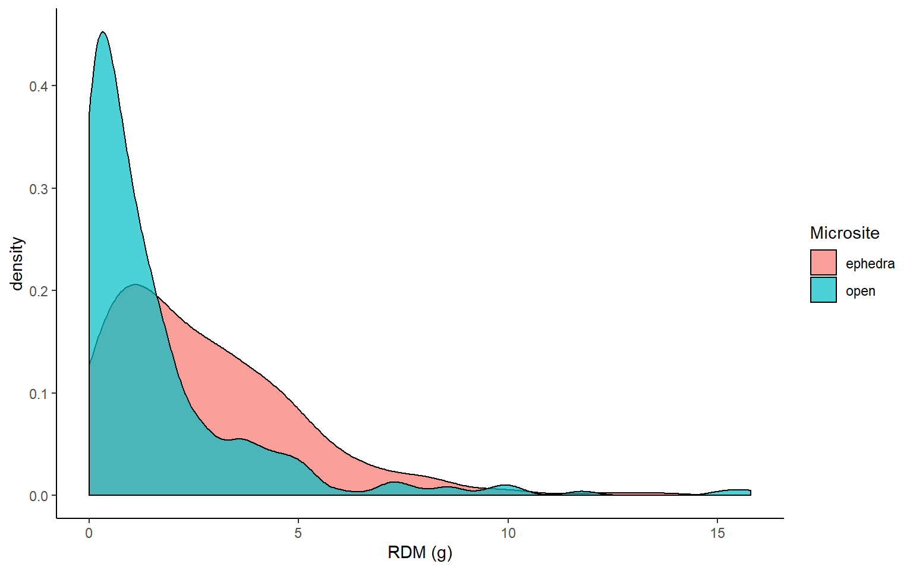

Figure A1: Distribution of RDM collected for each microsite over all sites.

**LITERATURE CITED**

Canty, A. J. (2002). "Resampling methods in R: the boot package." The Newsletter of the R Project Volume **2**: 3.

Liu, R., et al. (2014). "Effect of naturally vs manually managed restoration on ground-dwelling arthropod communities in a desertified region." Ecological engineering **73**: 545-552.

Liu, R., et al. (2016). "Changes in ground-dwelling arthropod diversity related to the proximity of shrub cover in a desertified system." Journal of arid environments **124**: 172-179.

Siemann, E. (1998). "Experimental tests of effects of plant productivity and diversity on grassland arthropod diversity." Ecology **79**(6): 2057-2070.